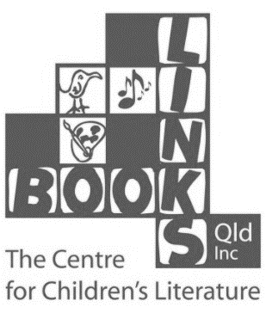
Sharing Stories 2014
Connect to Reading
with authors and illustrators

BOOKING FORM

Book early – only 100 places available
Maximum 10 students per school

One form per child

Name: _________________________ | Age: _______________
Address: __________________________________________________________
_________________________________________________________________
School: _________________________ | Phone: _________________________
Email: ____________________________________________________________
Special dietary needs: _______________________________________________

RSVP by August 18, 2014
___________________________________________________________________
Scan and email completed form with EFT details to info@booklinks.org.au
Book Links (Qld) Inc. - BSB 084 447 - AC # 599 221 626 Ref. Sharing Stories
OR
post completed form and cheque to Book Links, PO Box 415, ASHGROVE 4060

A confirmation email will be sent. This needs to be shown at the door.
__________________________________________________________________

