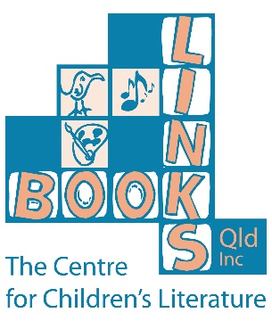

“Our mission is to link people and groups throughout the community with stories and experiences to build literacy and learning, so as to enrich lives.”

**Donation Form**

**Book Links (QLD) Inc.**

**ABN: 12 004 044 937**

**Please find enclosed my donation of:**

$20 $50 $100 $200 $500 other: ____________

**Full Name:** ______________________________________________

**Address:** ______________________________________________

_________________________ **Post Code:** _________

**Email:**  ______________________________________________

**Phone:** ______________________________________________

**Please find enclosed my cheque for:**

$20 $50 $100 $200 $500 other: ____________

**Please charge the amount below to my: MasterCard Visa**

$20 $50 $100 $200 $500 other: ____________

|  |  |  |  |  |  |  |  |  |  |  |  |  |  |  |  |  |
| --- | --- | --- | --- | --- | --- | --- | --- | --- | --- | --- | --- | --- | --- | --- | --- | --- |
| **Card #:** |  |  |  |  |  |  |  |  |  |  |  |  |  |  |  |  |

**Expiry Date: __ / __ / __ Name of Cardholder: _______________________________**

**Signature: _____________________________________________________________________**

**Register of Cultural Organisations under Subdivision 30-B of the *Income Tax Assessment Act 1997 –*** The Book Links (QLD) Inc. is a tax-deductible fund listed on the Australian Government’s Register of Cultural Organisations maintained under Subdivision 30-B of the *Income Tax Assessment Act 1997*.

**DONATIONS OF $2.00 OR MORE ARE TAX-DEDUCTIBLE**