ONLINE CHILDREN’S STORIES

SITE NAME | URL | WHAT YOU WILL FIND THERE
Storyline Online | https://www.storylineonline.net/ | - professional actors read the books  - includes close-ups of the book pages  - has subtitles  - teacher’s guide included for most books  - includes suggested grade level
Kidlit TV  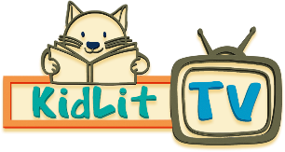 | https://kidlit.tv/ | - Tv show about story makers  - Includes “Read Out Loud” story time  - Includes children’s literature podcasts for kids  - “Ready, Set, Draw” guides students through drawing a picture book character  - Section with more resources for teachers called “For Grownups”
Save with Stories | https://www.instagram.com/savewithstories/  NOTE - Uses Instagram | - Hollywood stars reading out loud children’s books  - Double click on video to make it full screen  - Ability to see book pages well is limited
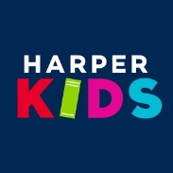  Harper Kids (Youtube Channel) | https://www.youtube.com/user/HarperKids | - Stories read out loud by the author  - Included subtitles
Read Brightly  Educational Resources and Activities to Use with Children while they are at home. | General Site Address  https://www.readbrightly.com/  Storytime videos – Read Out Loud  https://www.readbrightly.com/topics/brightly-storytime/  Youtube Channel  https://www.youtube.com/channel/UCvQagFNHMrGgQpYunk4rHXg | - Resources and articles about reading and children from 0-18 years of age  - Read Out Loud Video Storytime
Reading Pioneers Academy | https://www.youtube.com/channel/UC6Z9R-dZ7UPgeBCUUlnG3-w | - Popular picture books read out loud
Audible – Online Audio Books | https://stories.audible.com/discovery | - A collection of Free Online Audiobooks for children through to teens
Fairy Tales and Storytime for Kids – Youtube Channel | https://www.youtube.com/user/preschoolers123/videos | - Most popular classic fairy tales, princess & bedtime stories for kids in full HD animation
Stay at Home Storytime with Oliver Jeffers – A Book A Day  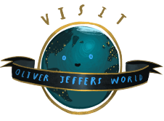 | https://www.oliverjeffers.com/abookaday/ | - Oliver Jeffers reads his books out loud
“The Very Hungry Caterpillar” read by Eric Carle  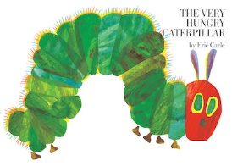 | Eric Reading his book  https://www.youtube.com/watch?v=vkYmvxP0AJI  An Animated version  https://www.youtube.com/watch?v=75NQK-Sm1YY | - Eric reads out his most well-known book
“Where’s my Teddy”  read by Jez Alborough  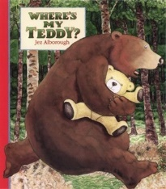 | Jez reads his book  https://www.youtube.com/watch?v=e9w2We3_RM0  Animated Version  https://www.youtube.com/watch?v=535aeHPS1J4 | - Jez reads out his most well-known book
David Walliams | https://www.worldofdavidwalliams.com/elevenses/ | - David is releasing a book a day online  - Children’s humorous books for various ages
Adam Wallace | http://www.adam-wallace-books.com/free-adam-wallace-drawing-ebook/  http://www.adam-wallace-books.com/2019/11/07/download-a-free-book/ | - Australian author/illustrator shares his how to draw rhyming books for free

